# Guided Capstone Project Report

## Recommendations for Big Mountain Resort

Big Mountain Resort currently charges $81 per ticket. Our goal was to predict ticket prices, using the data on 330 US resorts to help determine pricing strategy for the BMR.

The early exploration of the data demonstrated a strong correlation of adult ticket prices with the following data features across resorts: *vertical drop*, *fastQuads*, *Runs*, and *Snow Making_ac*, as the heatmap plot in FIG. 1 shows below:

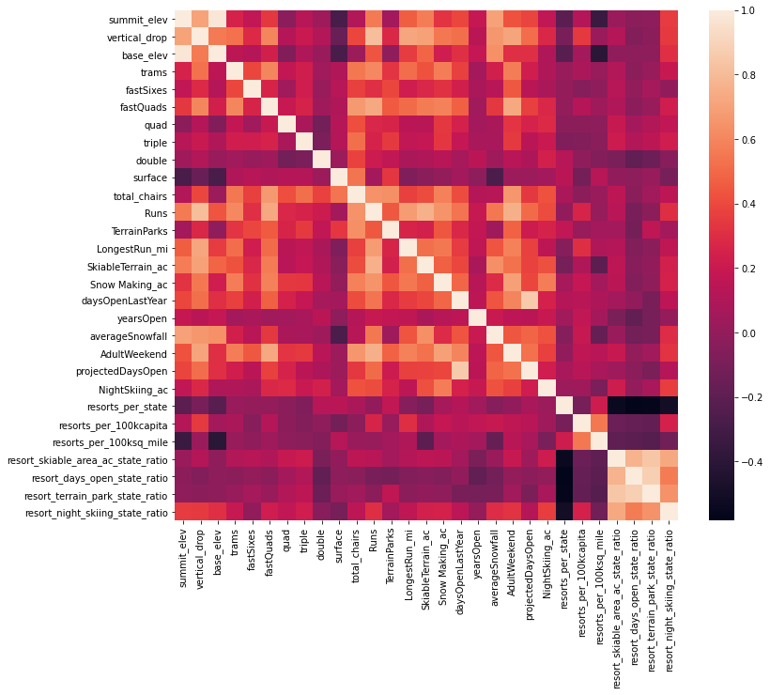

**FIG. 1**

We further proceeded with building and assessing the performance of the linear regression and random forest regressor models. The Linear Model further supported the initial patterns; here are the model coefficients representing features sorted in descending orders:

vertical_drop 10.767857

Snow Making_ac 6.290074

total_chairs 5.794156

fastQuads 5.745626

Runs 5.370555

LongestRun_mi 0.181814

trams -4.142024

SkiableTerrain_ac -5.249780

dtype: float64

The Random Forest Model returned the following top four features as: *fastQuads*, *Runs*, *Snow Making_ac*, and *vertical_drop* – please refer to FIG. 2 with a corresponding bar plot that shows the feature importance ranking.

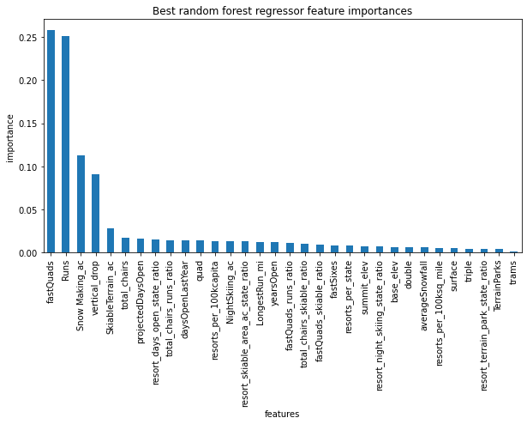

**FIG. 2**

While we found that the main features are common for both of the models, we needed to assess their respective performance to select the more accurate one. We have assessed the two models and concluded that the random forest model was a better choice, because it showed a lower cross-validation man absolute error than that of the linear model and also, less variability.

We built and ran the random forest model using 4 scenarios: 1 – closing down up to 10 the least used runs; 2 – increase the vertical drop by adding a run with 150 feet lower point, but at the expense of installing a new chair; 3 – same as scenario 1 but adding 2 acres of snow making; 4 – increase the longest run by 0.2 miles, a total of 3.5 mile, but requiring snow making coverage of 4 acres.

The results showed the following:

**Scenario 1:** As may be seen from below FIG. 1, closing down 2-3 runs reduces support for ticket pricing by $0.50. Closing of another 1-2 runs, i.e., total of 4-5 runs, does not result in further reduction in the price support; however, closing down 6 or more runs leads to significant drops in price support.

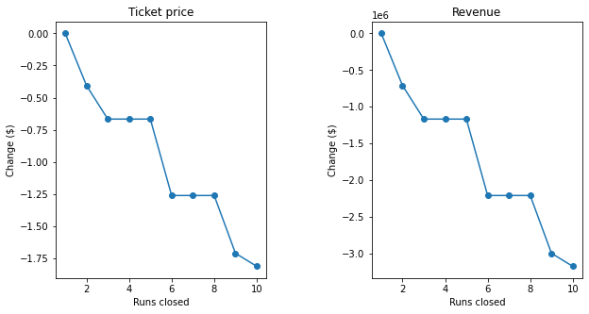

**FIG. 3**

**Scenario 2:** adding 150 feet drop increases the price support by $8.61 and leads to $15,065,471 in additional revenue projection; however, the additional Opex of $1,540,000 will need to be factored in in to determine the assumed profit margin.

**Scenario 3:** adding 150 feet drop AND adding the snow making area increases support for ticket price by $9.90 and leads to $17,322,717 in additional revenue projection; however, on top of adding $1,540,000 for the new chair, we will need also factor in the additional operating costs due to increased snow making capacity, to determine the assumed profit margin.

**Scenario 4:** increasing the longest run by 0.2 miles and adding 4 acres of snow making capability does not move the needle at all – it is obvious the random forest regression model ranked this feature as not important. Plus, the increased operating cost related to adding more snow making capacity will erode the profit margins.

We would recommend that BMR management considers Scenario 2 as the optimal strategy, because for the additional revenue increase of $15,065,471 or $8.60/ticket, BMR would net $13,525,471 in gross profit margins, or $7.72/ticket – after factoring in the increased Opex of $1,540,000 or $0.88/ticket.

Scenario 3, although suggesting even a bigger revenue increase in projected revenue of $17,322,717 or $9.89/ticket than in Scenario 2, is only a $1.29 increase in the ticket price, which after applying the increased Opex for the new chair, results in a $0.41/ticket gross margin increase. However, after applying the increased Opex for snow making capacity to cover 4 acres, this potential gain is likely get diminished further and even result in a negative delta.

Finally, we would also recommend BMR to close down up to 5 the least used runs – which may result in lowering the ticket prices by $0.50/ticket, but would also greatly reduce the operating expenses, so the overall gross profit margins would go up even further. We would recommend that BMR starts with closing down the first 3 runs to test the theoretical assumptions and then proceed with closing down the 4th and 5th runs accordingly.